

PRIME Clinic

*The PRIME (Prevention through Risk Identification Management and Education) Clinic identifies youth and young adults showing early signs of serious mental illness and provides treatment to prevent progression of illness.*

Connecticut Department of Mental Health and Addiction Services

*Preventing Psychosis*

The PRIME Clinic is an innovative pilot treatment program for youth and young adults ages 12-25 who are showing early signs of developing psychotic illness as diagnosed by a new category in DSM-5: Attenuated Psychosis Syndrome. Operated as a research clinic at the Connecticut Mental Health Center in New Haven for the last decade, PRIME is now transforming into a service clinic based on billable services and a new grant to DMHAS from the federal Substance Abuse and Mental Health Services Administration.

About 10,000 youth and young adults are at risk for developing psychosis in Connecticut at any one time. Fortunately, only about a third of those at risk actually develop the disorder. Costs to society for those that do progress, however, are high: estimable at roughly $2 million per individual over their subsequent lifetime, counting costs of treatment and value of lost work. Prevention offer hope of reducing this burden of illness.

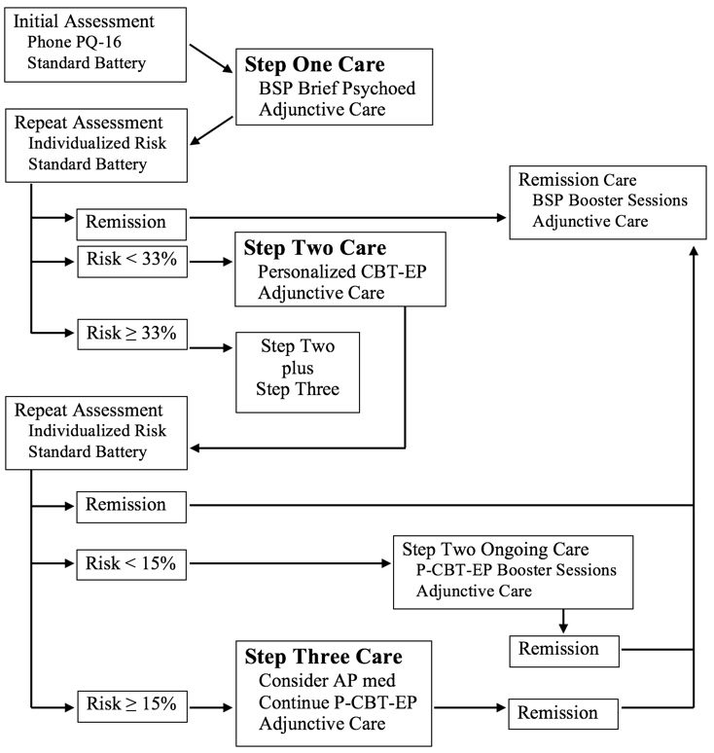

Youth and young adults will undergo individualized risk assessment using an innovative but multiply replicated clinical tool and will be offered stepped care based on individual risk.

In Step 1 patients will be offered brief support and psychoeducation. Patients who are at moderate risk after Step 1 will receive evidence-based cognitive behavior therapy in Step 2 along with medication if risk is high. Patients who remain at moderate risk after Step 2 may also elect medication in Step 3.

Working closely with DMHAS and with the network of child guidance clinics operated by the Department of Children and Families, PRIME hopes to help build treatment capacity for youth and young adults with Attenuated Psychosis Syndrome at multiple sites throughout the state.

***Program Goals***

1. Improve symptoms
2. Enable resumption of age-appropriate activities
3. Delay or prevent onset of psychosis

***Outcomes***

* 400 community education presentations over four years
* 175 enrolled patients over four years
* symptom improvement in ≥ 75%
* improved or maintained age-appropriate activities in ≥ 75%
* ≥ 50% reduction in progression to frank psychosis compared to predicted risk